Fidelity Court

Your monthly assessment is $250.00. You will need to set up a new payment option with our management company, please use the information below for checks, billpay and autodraft payments.

For Online payments, please visit www.onyxmanagementandconsulting.com and follow the link to “pay your dues online.” Please use 7064 for the Management ID FCUA for the Association ID and Your NEW account number to make payments. You will need to register a new account to make reoccurring online payments.

For checks and Billpay options, please mail to:
Fidelity Court UOA
c/o Onyx Management and Consulting, LLC
PO BOX 96693
LAS VEGAS, NV 89193-6693
When mailing a check or using billpay, please put your account number listed above in the “memo” section.

Payments are due the 1st of the month, no later than the 10th or subject to a late fee. Any payments sent to the previous Management will be forwarded to our attention.

We look forward to working with you.

Sincerely,
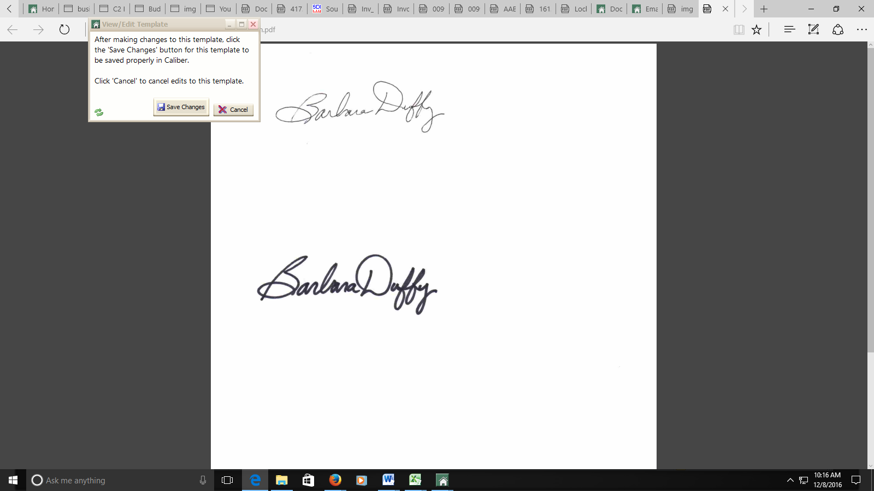
Barbara Duffy
President, Onyx Management and Consulting, LLC

